

Bronze = 15 Achievement Awards

Silver = 25 Achievement Awards

Gold = 35 Achievement Awards

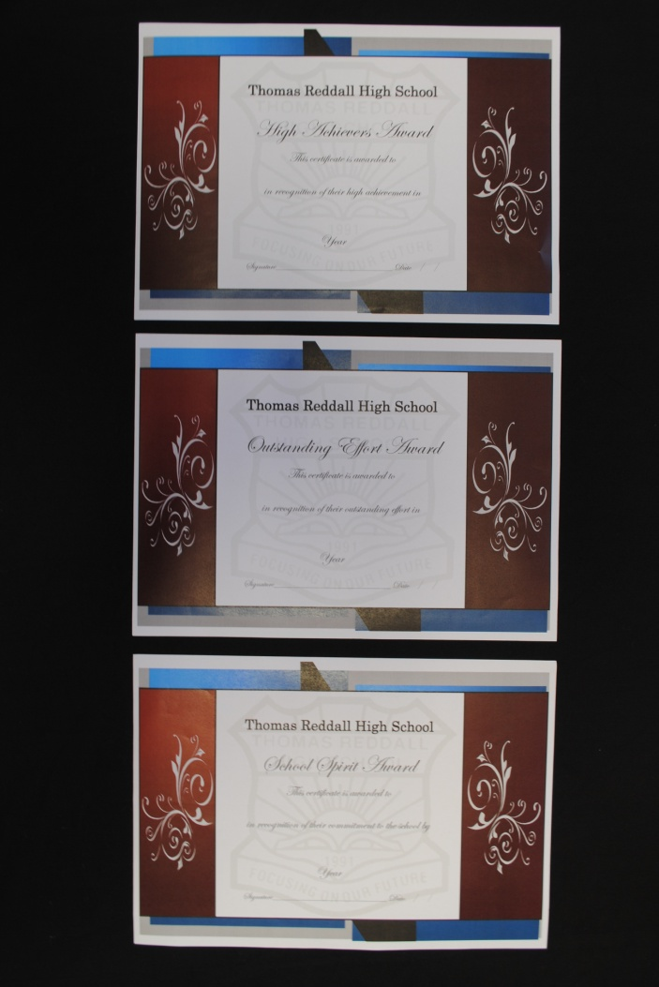

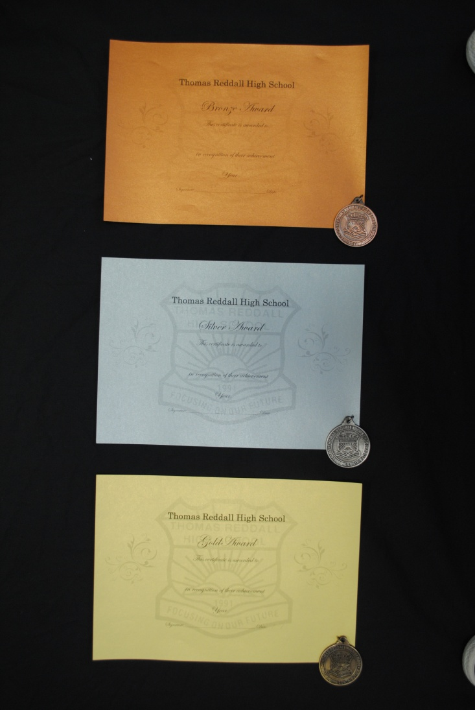

**High Achievers**

**Outstanding Effort**

**School Spirit**