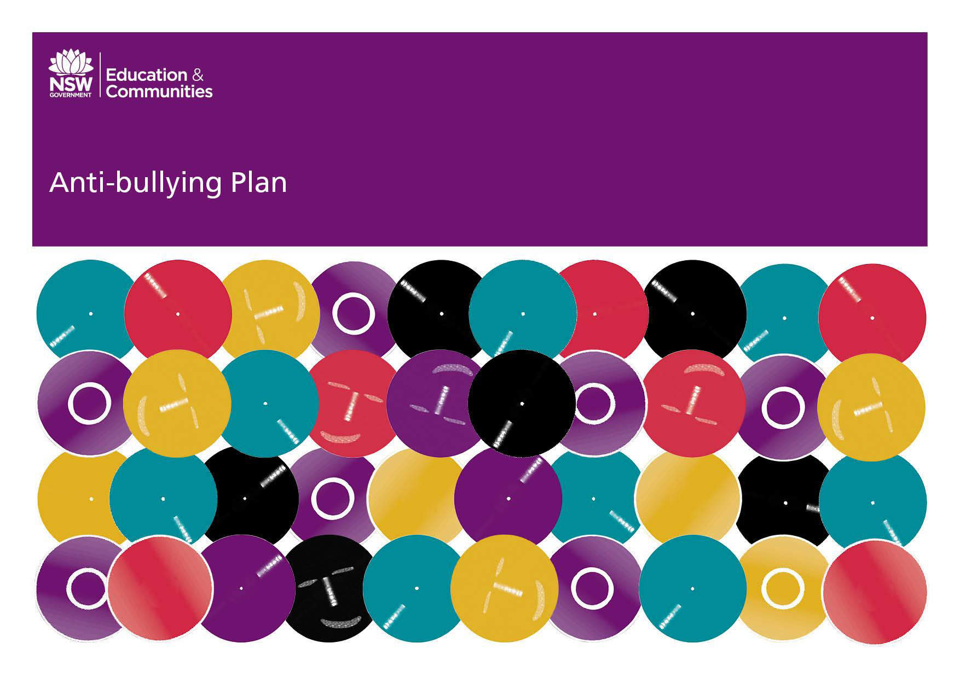
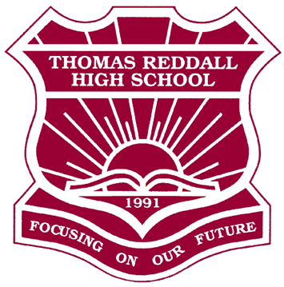

Thomas Reddall High School
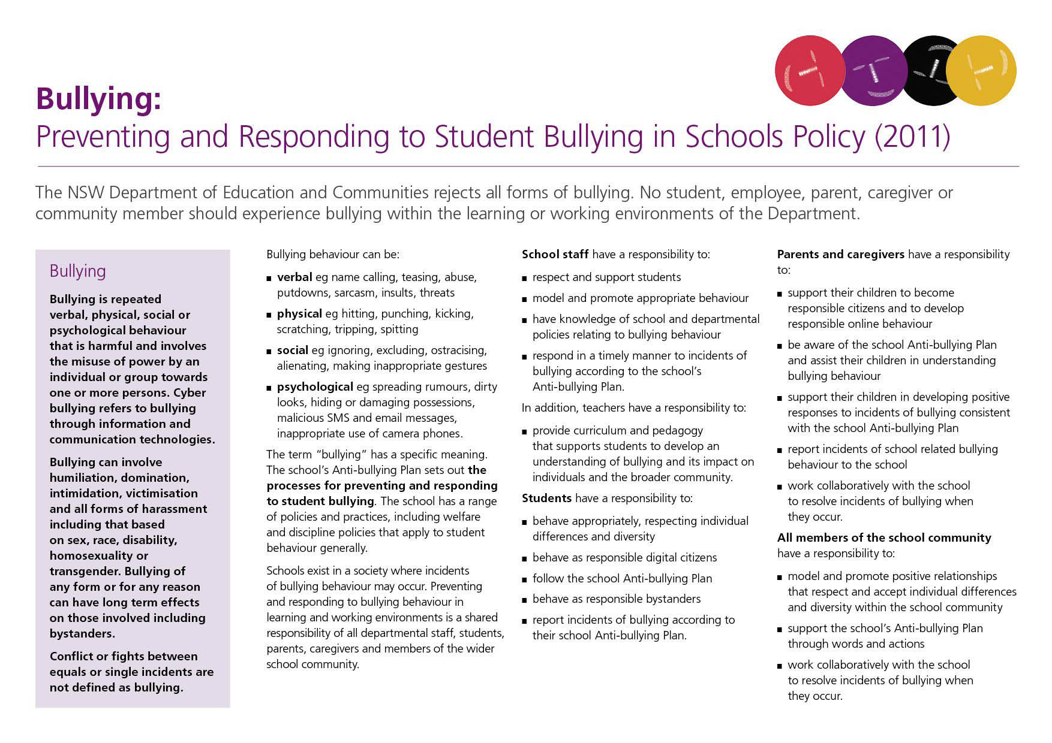

TRHS Anti-Bullying Plan
gestures.
Psychological – spreading rumours, dirty looks, hiding or damaging
possessions, malicious SMS, email and social network messages,
inappropriate use of camera phones.

Bullying behavior at Thomas Reddall High School is unacceptable and regarded as a serious issue because it can adversely affect the well being of the victim both now and into their future. All reports of bullying are taken seriously and handled in a sensitive and timely manner.

Preventing and responding to all forms of bullying is the shared
responsibility of all staff, students, parents, caregivers and members of
the wider school community.

Cyber-bullying is an intentional, repeated behaviour by an individual or
group to cause distress or undue pressure to others using technology. It
can be carried out by:
- Email
- Instant messaging
- Social networking sites
- Text and picture messaging

Bullying can include “bystander” behaviour where students support the bully rather than help the victim.

Harassment, discrimination and homophobia are all forms of bullying.
Students are expected to accept that others are different from them and
that discrimination or harassment based on race, gender, sexuality, socio economic status, disability or religion is behaviour that is not acceptable. Students should advise their teachers, year advisers, counsellors and the deputy principals if they experience or witness harassment and discrimination.

This plan outlines the processes for preventing and
responding to student bullying in our school and reflects
the Bullying: Preventing and Responding to Student
Bullying in Schools Policy of the New South Wales
Department of Education and Communities.

Statement of purpose
All members of the school community have the right to learn and work in
a safe and happy environment. The Thomas Reddall High School
community is committed to the development of quality relationships and
responsible behaviour. All expectations of the school are based on
principles developed from the Positive Behaviour for Learning (PBL).

Protection
Refers to those factors that increase the likelihood of positive wellbeing outcomes and guard against the effects of negative experiences.

Bullying is repeated verbal, physical, social or psychological behavior that
is harmful and involves the misuse of power by an individual or group

towards one or more persons. This includes, but is not limited to:
Verbal - name calling, teasing, sarcasm, insults, threats, abuse,
putdowns.
Physical – hitting, punching, kicking, scratching, tripping, spitting.
Social – ignoring, excluding, ostracising, alienating, inappropriate

The Anti-Bullying Plan – NSW Department of Education and Communities 2 TRHS 2017

All new enrolments are screened for potential issues through interview.

Response
Examples of school programs include:
Monitoring books – HT, Year Adviser, DP
Counselling and staff mediation
Staff development and information sessions
Individual and group workshops
Peer mediation
Sentral record
Risk Assessment Plan
Behaviour Management Plans
Annual Police School Liaison workshops
Sentral warnings
Pastoral Care Program
Year 6-7 Transition and Induction program
Both, victims and witnesses to bullying should report incidents to:

class teacher
teacher on playground duty
head teacher
year adviser
Welfare Coordinator
Deputy Principal
Principal.
Reported incidents will be addressed as soon as is possible. Once reported by the relevant staff member planned interventions will be organised and managed in consultation with the members of the Welfare Team with the support of classroom teachers and Head Teachers.

Prevention
Strategies and programs:
Year 6 to 7 Transition Program and Orientation.
Peer Support Program.
Positive Behaviour for Learning (PBL) program for whole school.
PD/H/PE curriculum focus on bullying.
Welfare Team including Year meetings, Pastoral Care, Welfare meeting
For discussion of particular issues, Student monitoring
- Sentral as a warning
- Police School Liaison Officer workshops.
Student diary.
Mobile phone policy
Crossroads Program.

Early Intervention
Staff and students are encouraged/expected to report any bullying
concerns as soon as possible to Faculty HT, Year Group HT,
Year Advisers and Deputy’s.

The Welfare Coordinator will notify the relevant Year Adviser
regarding any new enrolments that are identified as:
having previously experienced bullying
being at risk of developing long-term difficulties with social
relationships identified as engaging in bullying behaviour

The Anti-Bullying Plan – NSW Department of Education and Communities 3
TRHS 2017
Managing Student Conflict
Conflict occurs in school just as it does in the communities that the schools serve. Thomas Reddall High School utilises a range of procedures designed to prevent conflict
from occurring and to manage or to resolve conflicts as they become apparent. Positive relationships are supported through various strategies including: Year Meetings,
Anti-bullying programs, Peer Support and Positive Behaviour for Learning initiatives.
Conflict occurs
Parent contacts school and
is referred to appropriate
Year Adviser

Student, teachers or
bystanders behave
assertively and tell the
person to stop

Conflict continues
Teacher interviews the
students and seeks to
resolve the issue
If serious or repeated acts
of aggressive behaviour,
refer to Deputy Principal

Conflict continues
Conflict continues
Deputy Principal interviews
student/s-Principal
informed.
Teacher records incident
on Sentral and informs Year Adviser and/or Head Teacher Welfare

Year Adviser interviews
student/s and attempts
mediation and resolution
Year Adviser contacts
parents

Suspension Caution
Year Adviser may make
informal contact with
student/s

If necessary, refer to
School Counsellor
Refer to HT Welfare
Further conflict

Suspension
Monitoring of resolution
by Year Adviser and/or HT
Welfare
HT Welfare interviews
victim and perpetrator/s
and determines action.
Year Adviser monitors
students/s for continued
patterns of conflict

The Anti-Bullying Plan – NSW Department of Education and Communities TRHS 2017 4
Parents and caregivers for involved parties will be notified as regularly as occur involving student, staff and parent surveys, analysis of Sentral/
required by telephone or in written form within the bounds of privacy suspension data.
legislation as part of the management of incidents.
Additional Information
Parents and students should be aware that any incidents involving
Bullying: Preventing and Responding to Student Bullying in Schools Policy

Protecting and Supporting Children and Young People Policy

Support services:

Police Youth Liaison Officer (YLO)


School Liaison Police officer (SLP)

School Counsellors – Justine Berghouse, Belle Donachie & Emma Shaw
serious violence, illegal drugs, weapons or major criminal activity will be
reported to the School Safety and Response Hotline and to the local
police.

In 2010, the NSW government introduced new legislation and procedures
for child protection called “Keeping Them Safe”. Under this legislation, the
government established a threshold of significant harm” The Department
of Community Services (DoCs) will act when the threshold is met. In
serious and urgent matters, the school will contact the police.

Complaint handling procedures
Kids Helpline 1800 55 1800
Parents are encouraged to discuss classroom based concerns regarding
their child with the teacher first. If they are not happy with the result, or

Bullying. No Way! www.bullyingnoway.com.au

Mindmatters http://www.mindmatters.edu.au/default.asp

National Coalition Against Bullying www.ncab.org.au

Headspace https://www.headspace.org.au/

Beyond Blue http://www.beyondblue.org.au 1300 22 4636

they do not feel it is appropriate to talk to the teacher they can phone
and/or make an appointment to talk with the Head Teachers, Year
Adviser or Deputy Principal (in that order). At Thomas Reddall High School
we encourage parents to contact us immediately.

Staff concerns, Sentral entries and Progress & Conduct reports can be
used to help identify patterns and information about bullies, victims and
witnesses.

This TRHS Anti-bullying Plan will be published on the school website and
also kept in print form in the school office and by all faculties and
distributed to each staff member.

As part of the scheduled review and creation of the School Management
Plan (every three years) an ongoing review of the Anti-Bullying Plan will

The Anti-Bullying Plan – NSW Department of Education and Communities 5
TRHS 2017

